Carreg Fran, Ogwen: revised interim mini-guide
Harold Walmsley, 30th July 2022

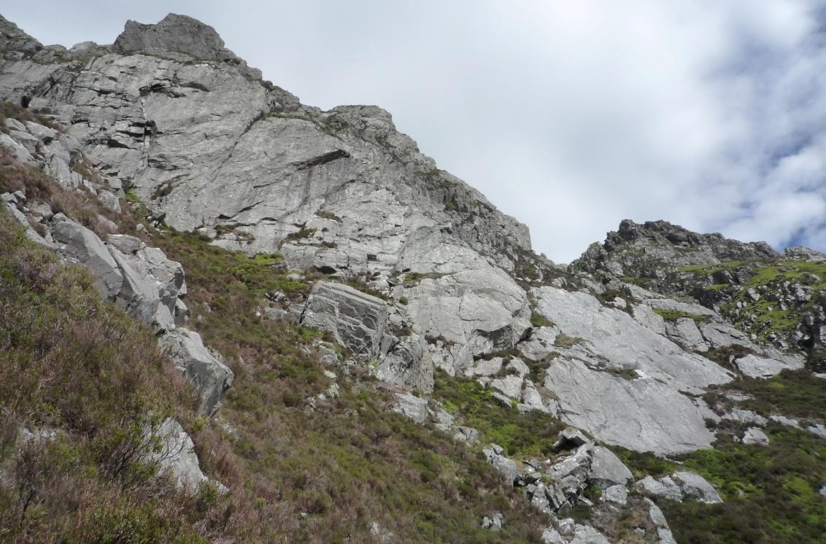
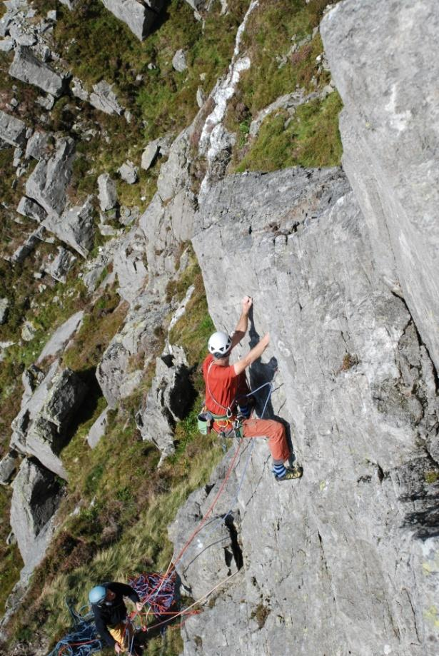 | 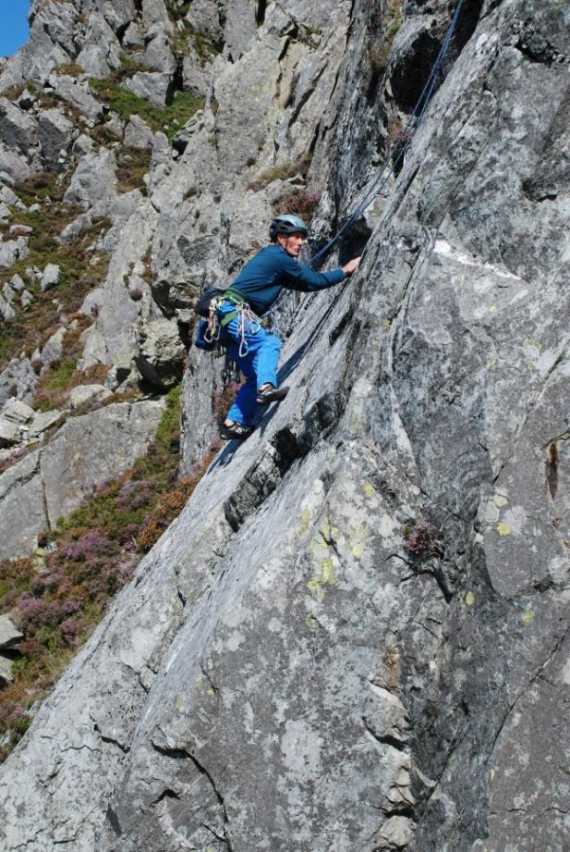

Carreg Fran

Location, layout and general character
Carreg Fran (SH 649 626) is the wall of pale grey rock that overlooks Nant Ffrancon from the top left-hand corner of the flank of Pen yr Ole Wen. It lies high above the Sheep Pen boulders and is well seen from the A5 just above Ty Gwyn. The approach takes about 1½ hours from the road.
Like nearly all bands of rock on this hillside, it slants diagonally down to the right. There are no breaks to separate it into buttresses but the character changes from left to right so it divides naturally into three sectors: the Pillars Sector top left, the Central Sector, which is, unsurprisingly, in the middle, and the Slabs Sector bottom right. Above the Central and Slabs Sectors, the top of the crag forms a ridge, the “Top Ridge”, that runs parallel to the base of the crag and about 80 m higher up the hill.
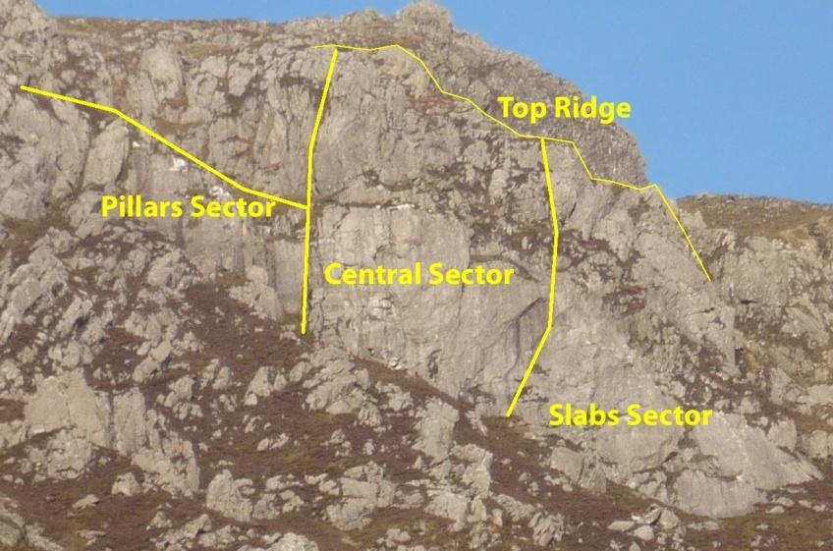
Crag sectors
The crag lies between the altitudes of 660 m at the bottom of the slabs and 780 m at the top of the Central Sector. It faces WNW and gets afternoon sun. The rock is rhyolite (Braich Ty Du tuff) with excellent friction. It is generally sound but there are occasional blocky patches. The character of the climbing varies from sector to sector. A wide range of rock features is found including cracks, grooves, ribs, overlaps, steep walls and slabs. The style of climbing is correspondingly varied. Some pitches are very well-protected, others are hard to protect or just plain runout.

Approach

Outline
Start from the A5 in Nant Ffrancon just above Ty Gwyn. There is convenient parking in the lay-bys below the Sheep Pen boulders (SH 642 624). The crag base could be reached directly via the boulders but it is easier to go to the top of the crag first and then descend. This involves gaining the northwest ridge of Pen yr Ole Wen, following it to a shoulder just above the top of the dry stone wall, traversing right and slightly down to the top of the crag, scrambling down to an in-situ abseil anchor and abseiling to the base (the crag is surrounded by a complex maze of smaller buttresses that make a purely scrambling descent awkward and circuitous).

Details of the walk to the crag top
Sections of the northwest ridge of Pen yr Ole Wen are steep and loose if taken directly but there is a more devious line with gentler gradients and good footing all the way. This line is noticeably easier and is now described in detail. The young and fit, or the impatient, can skip these details and go straight to the Descent section, which describes how to find the abseil point. Letters in brackets and italics refer to the waymarks labelled on the approach map.
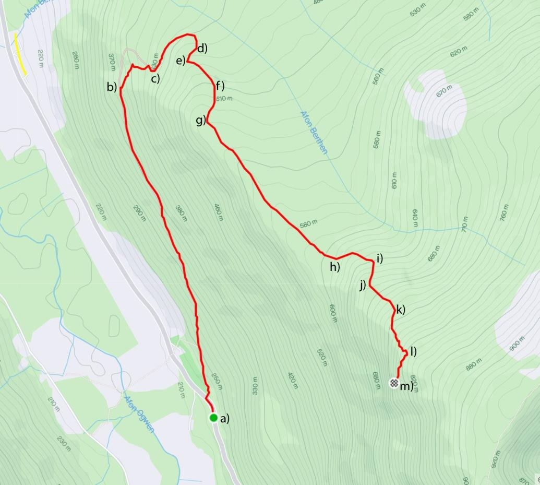
Approach map
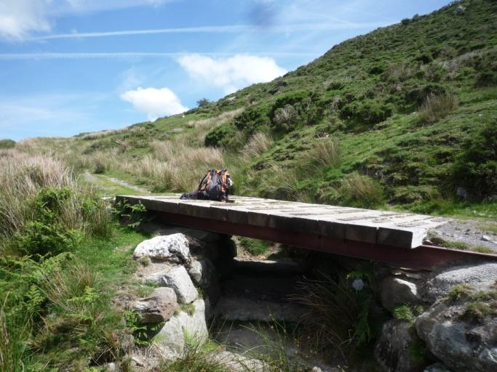 | 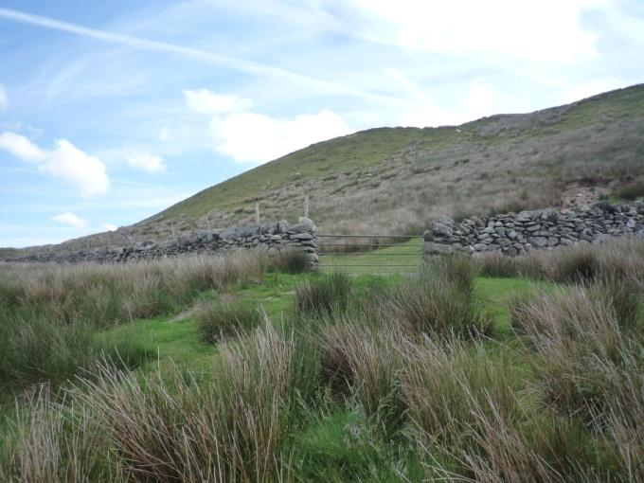
The wooden bridge and skyline hawthorn (b) | The gate and stile (c)
From the parking, (a), go about 100 m down the A5 and follow the track that climbs diagonally up the hillside towards Gerlan. After about 25 minutes it crosses a wooden bridge, (b). A few metres after the bridge, cross the ditch on the right and follow an old track (now a sheep path) up and left past a solitary hawthorn on the skyline. After the hawthorn, head for the lowest visible point of a wall and fence that run together down the hillside above. Here, (c), a gate, and a stile (both hidden from below), cross the wall to the open hillside.
The steeper ground above the gate can be taken directly just left of the wall but it is easier to follow the reed-infested track that runs clockwise round the toe of the ridge. Where the track curves sharply back right and gets lost in the reeds, (d), turn 90° right and follow a faint path up grass at the left edge of the reeds until the angle eases, (e). Re-join the track, marked by a line of reeds, as it traverses leftwards across the hillside, slants right (uphill), (f), and fades. Where it fades, continue in the same direction. A gate, (g), on the crest of the ridge soon comes into view. Join the direct ridge path by the gate and follow it until the ridge steepens again, (h). From here, the direct line up by the wall involves steep, loose scree so take the quad bike track that runs diagonally up the hillside to the left (the upper of two visible tracks). It eventually cuts back right, (i), up a ramp to rejoin the wall. As the ramp levels off, (j), just before the wall, follow a faint path almost straight up then a little left to a shallow grassy rib. From the top of the rib, (k), traverse into the rightmost of the grassy breaks that run up into the stony area above and bear diagonally right to follow the upper part of the wall, now above all scree, to its end. The shoulder, (l), about 70 m beyond the top of the wall is the high point of the walk in. It is labelled the “1st shoulder” in the schematic diagram below.

From the 1st shoulder, a descending traverse across the heads of three gullies and two intermediate shoulders leads to a 4th shoulder marked with a small cairn (1 h 15 to 1 h 45 from the road).

Descent
The cairn on the 4th shoulder marks the start of the scramble down to the in situ abseil anchor but the anchor cannot be seen from here. On a first visit, it may be helpful to spot the anchor before scrambling down. To do this, continue the descending traverse to the 5th shoulder, (m), which is the top of Motivation (SH 650 625). The anchor can be clearly seen from here by looking down to the right.
To reach the anchor, start from the cairn on the 4th shoulder, descend grass on the true left side of the 3rd gully for about 15 m, cross the highest notch in the rib on the left and descend a vegetated groove (care with loose stones) to a grassy terrace. Traverse down and left on the terrace, keeping just below the rocks. Cross a rib above a pinnacle block and descend a short rock groove and a few metres of grass to the anchor. Both the schematic diagram of the crag top and the overview photo show the line of the scrambling and the location of the anchor. On the abseil, keeping to the left (looking in) leads, in 27 m, to the lowest level of the stepped bottom lip of a rock crevasse. From here, an easy bilberry traverse leads into the bed of the gully that runs below the Pillars Sector. A further short scramble reaches the foot of Motivation and a sketchy trail leads on down to the Slabs Sector.
NOTE: A 35 m abseil reaches all the way to the gully bed. If two climbing ropes are used for this, throwing the ends down tends to land them in the rock crevasse where they might get stuck. This can be avoided by carrying the ends down until they can be dropped clear of the crevasse.

Scrambling out
If it is necessary to scramble back out, the easiest line is well to the left as shown in the crag overview. From near the start of Motivation scramble up the gully past the bottom of the abseil line to an impasse then descend to the foot of the rock rib on the left where there is a distinctive leaning boulder. Alternatively, less effort but harder to navigate, traverse the hillside leftwards from near Motivation to the leaning boulder. If forced up, you will have to descend a little to reach it. Continue traversing round the next, more broken, rib keeping as high as is comfortable. The gully beyond this rib (the 2nd gully) provides the shortest way to the top but there is a precarious move to enter the upper section (nasty if wet). If the precarious move is unappealing, continue traversing to the next gully (the 1st gully). This leads steeply but easily to the top mainly via bilberry slopes. The precarious move can be reached more entertainingly by going up diagonally left from the leaning boulder to locate a cleft that cuts through the second rib higher up. It has an arch formed by a wedged block. Pass under the arch. The precarious move is just beyond.
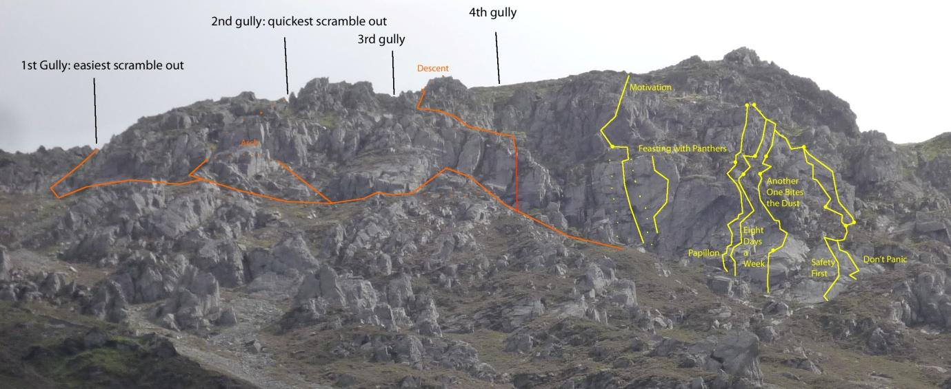
Crag overview: routes in yellow, scrambling in orange, abseil in red

Routes
The routes are described sector by sector.

Pillars Sector
The Pillars Sector is the left-most area to give worthwhile climbing. Continuous rock is found primarily below the terrace that gives access to the abseil station: above the terrace, the rock is too broken for climbing except, perhaps, at the extreme right above the Fourth Pillar. As the abseil descends the corner between the Second and Third Pillars, access is relatively convenient.
On the far left, a wall with a pair of V grooves in its right side lies above the rib that forces the scramble out to descend. To the right of this wall are four pillars that are labelled First to Fourth from left to right. These are quite prominent from the car park. The only existing route lies on the First Pillar which tops out on the abseil access terrace. It allows climbers to finish a day off with a shorter, more convenient route than the multi-pitch outings further right, whilst still giving good climbing. There is scope for more.
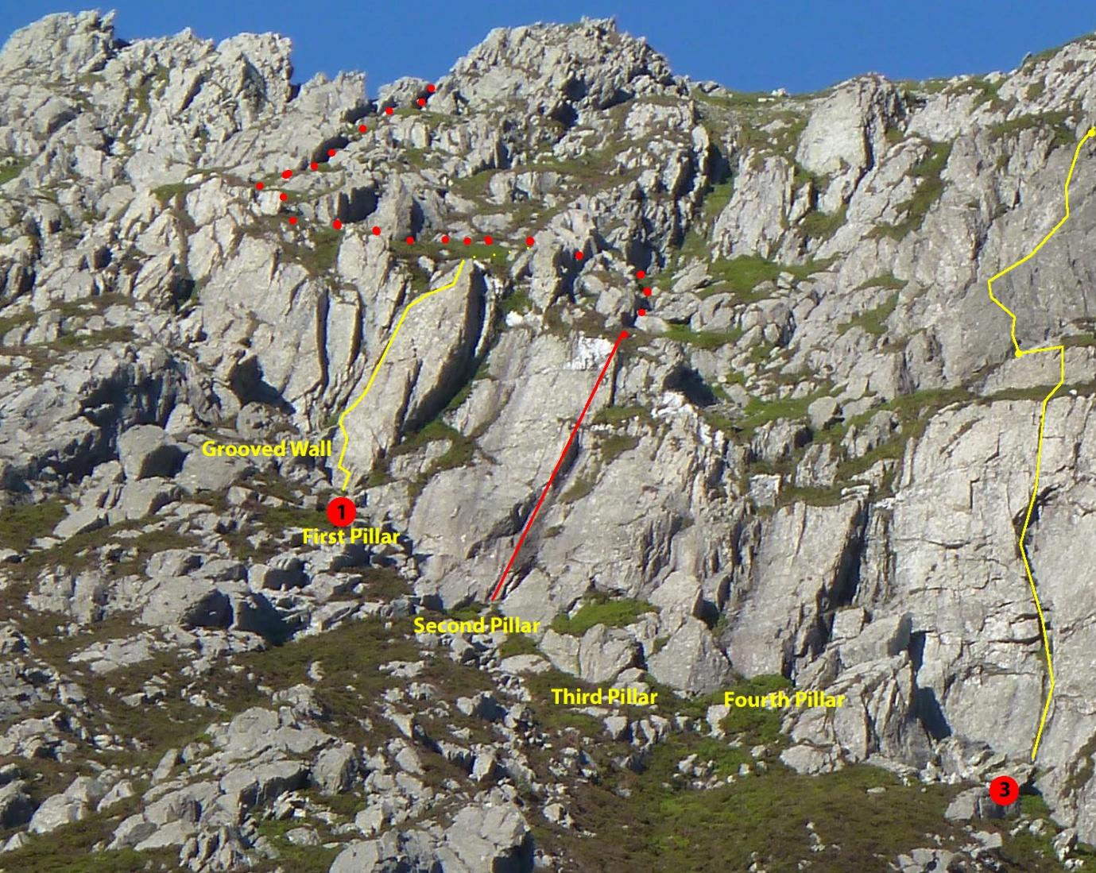
Pillars area routes (descent and abseil in red)
The First Pillar looks cigar-shaped from some angles so the first route is named after a cigar.
- CheRoute, (25 m of rock, 32 m to recommended belays), E1 5b: Good climbing near the left rib of the First Pillar passing a large poised flake. If you think the flake looks alarming it can be completely avoided. Start on the slab just left of a flying buttress and head up left to a flake below a thin crack. Climb the crack to a ramp. Step left to footholds on the left rib. From the highest good foothold climb the right side of the rib on opposing sidepulls, crux, to a good slot in a crack. Reach a jug, then a ledge. Keep left on the rib if you want to avoid the flake. Continue up easy cracks/grooves in the upper rib and follow the top of a flake rightwards to finish in the centre of the pillar. The most rope-friendly belays are threads and nuts on blocks about 7 m further back (32 m).
H.Walmsley, C.Calow 29/07/2022
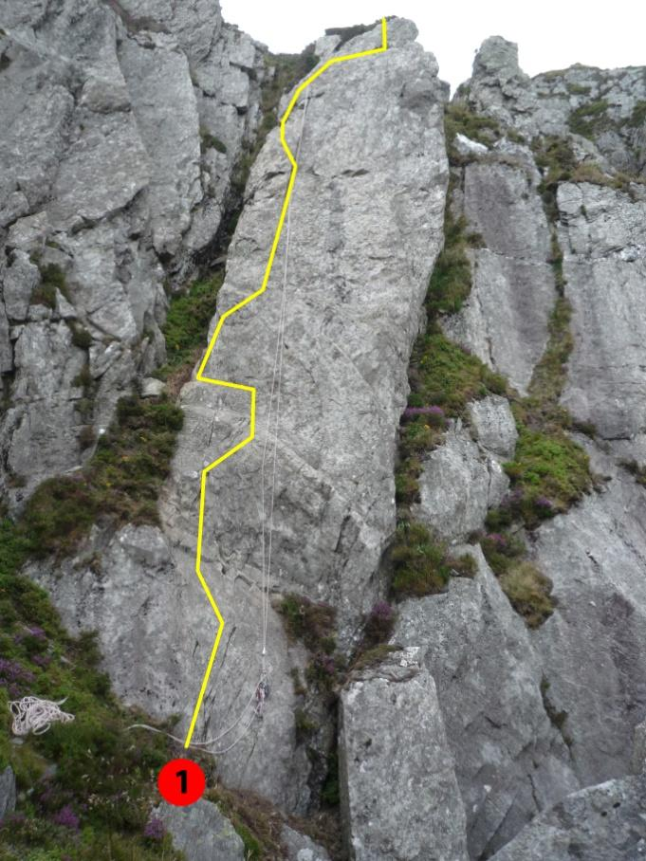 | 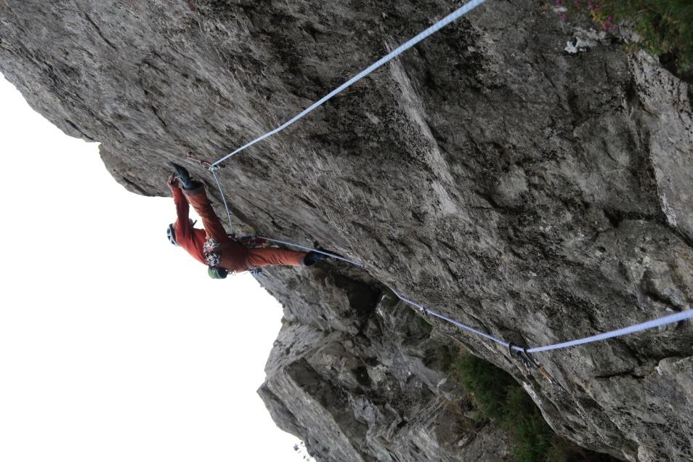
First Pillar | Placing gear by the crux of CheRoute

Central Sector
The Central Sector lies to the right of the Pillars. It consists of steep walls, cracks, grooves and big overlaps. There are four recorded routes. Only Motivation, the first and best of the newer routes, can be fully described. The rest date from the 1990s and full descriptions are not available. For Un-named (Route 2) and All in Black only the approximate locations and the grades suggested by the first ascentionists are known. For Feasting with Panthers there is also a topo. These older routes have not been given star ratings but look potentially good.

- Un-named, E3/4: The original description: "The blocky pillar left of the central groove" is the only written information but the presence of a stuck hex was mentioned verbally. The stuck hex (with karabiner) can be spotted high on the left from near the base of Motivation if you know where to look. This confirms that the "central groove" is Motivation and shows the general line.
Elfyn Jones, Mike Turner (late 1990s?)

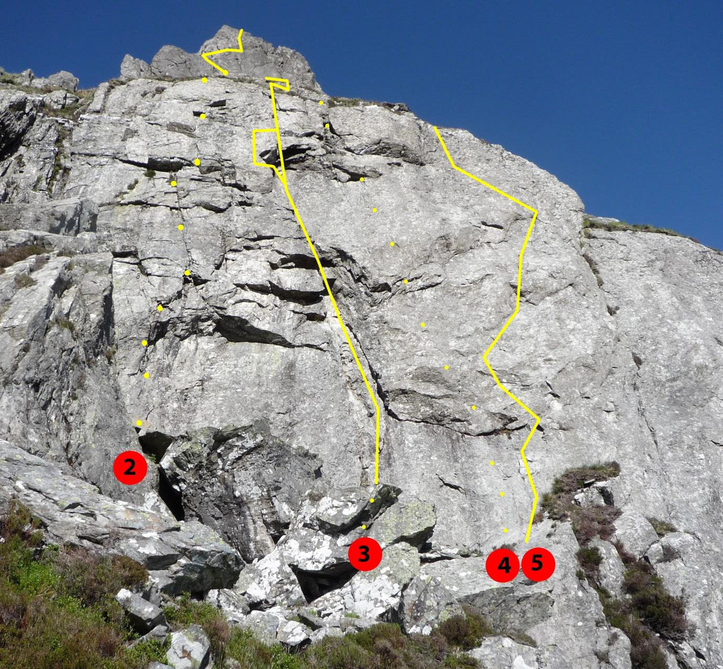
Central Sector: dots show the approximate locations of Routes 2) and 4)
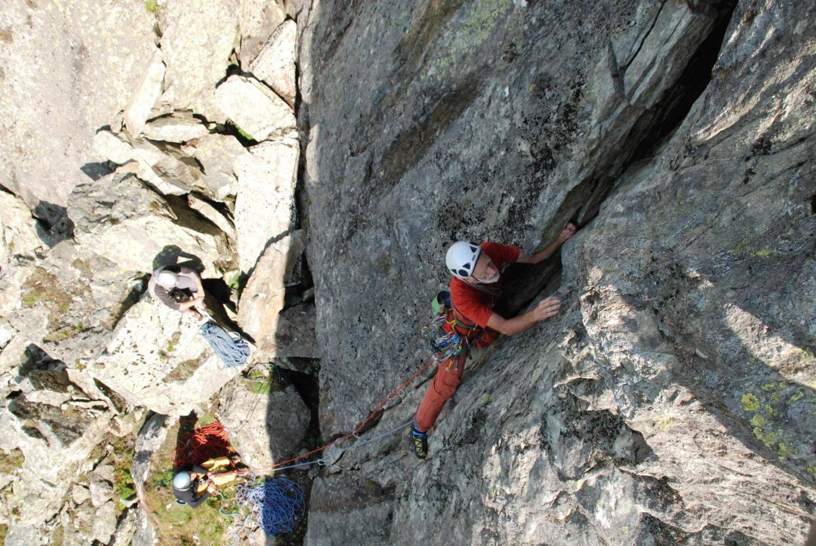
The initial cracks of Motivation
- Motivation, 80 m, E3, 5c (5b/c), 5c ***: This excellent route with two contrasting pitches takes the prominent crack system near the left end of the Central Area and the tower above. The initial cracks and chimney are often damp but can be climbed if the walls on either side are free of seepage. The Direct variant on P1 is as slow to dry as the lower cracks and depends more on friction so needs longer to be climbable but the Original variant dries quickly. The first pitch can be done on its own by scrambling to the top via the abseil point. This gives a good, well-protected pitch that is more like E2 5b/c**. Start on blocks below the crack system.
P1. 40 m, 5c: Climb the cracks and bulging chimney to a groove. Bridge and layback to a downward pointing spike at the overhang and pull round on good holds. Continue up the crack to a heathery ledge. Take the next short wall on the right and move left to belays.
Variation: Original variant (5b/c): Move left round the rib below the downward-pointing spike (just below where it starts to lean) and climb a subsidiary crack via a long reach (5c for the short). Move right at the good break above the overhang to regain the main line.
P2. 25 m 5c: A serious pitch with good rock but awkward protection. From the flat-topped block on the left above the stance, pull on to the poorly-protected wall and trend leftwards up a very shallow scoop. Small wires (hard to spot) may protect the pull round onto the slab above. Climb the slab to its apex. Place as much gear as you can and make a committing move to stand on the ramp up and right. Shuffle slightly right and reach for a good jug on the wall above. A couple more moves lead to easy ground and a stance on blocks.
P3. 15 m: Easy ground to the top.
Original variant: H. Walmsley, C. Calow, R. Newcombe 14/09/2020, Direct: H. Walmsley, M. Bailey 21/09/2020.
- All in Black, E5 6a: Original description: "Open wall left of Feasting with Panthers". A topo of uncertain provenance shows it finishing up the hanging crack right of the top of Motivation p1 so it appears to go somewhere between Motivation and Feasting with Panthers.
Mike Turner, Elfyn Jones, (late 1990s?)
5) Feasting with Panthers E4/5: The line shown in the Central Sector picture is based on an old topo. Several protection pegs can be seen from the ground. They have been added after the first ascent and are in an unknown condition.
Nigel Shepherd early 1990s.
Right of Feasting with Panthers there is an imposing but dirty leaning groove then an impressive wall with a prominent big overlap that is clearly visible both in the crag overview picture and about half way up the left side of the first Slabs Sector topo. The slanting corner below the big overlap and left of the slabs forms the boundary between the Central and Slabs Sectors. There are no known routes between Feasting with Panthers and this boundary.

Slabs Sector
In this sector, the lower part of the crag comprises three layers of slab running in steps down and right. Above these is a band of heather capped by a line of upper buttresses that provide finishing pitches. The two left hand slab layers steepen considerably both at the bottom and as they approach the heather band but the right hand layer remains at a low angle all the way.
There is, obviously, a lot of slab climbing here but the steeper rock provides some of the cruxes, notably on Papillon and Another One Bites the Dust.
At present (July 2022) there are five routes in the Sector and one, Papillon, has a substantial variation. Papillon and Eight Days a Week take the left hand slab layer, Another One Bites the Dust takes the central layer and Safety First and Don’t Panic take the right hand layer.
The first topo for the Slabs Sector shows all of these routes in their entirety. The next one shows, in more detail, the starts and the climbing up to the heather band on Papillon, its variations, Eight Days a Week and Another One Bites the Dust.
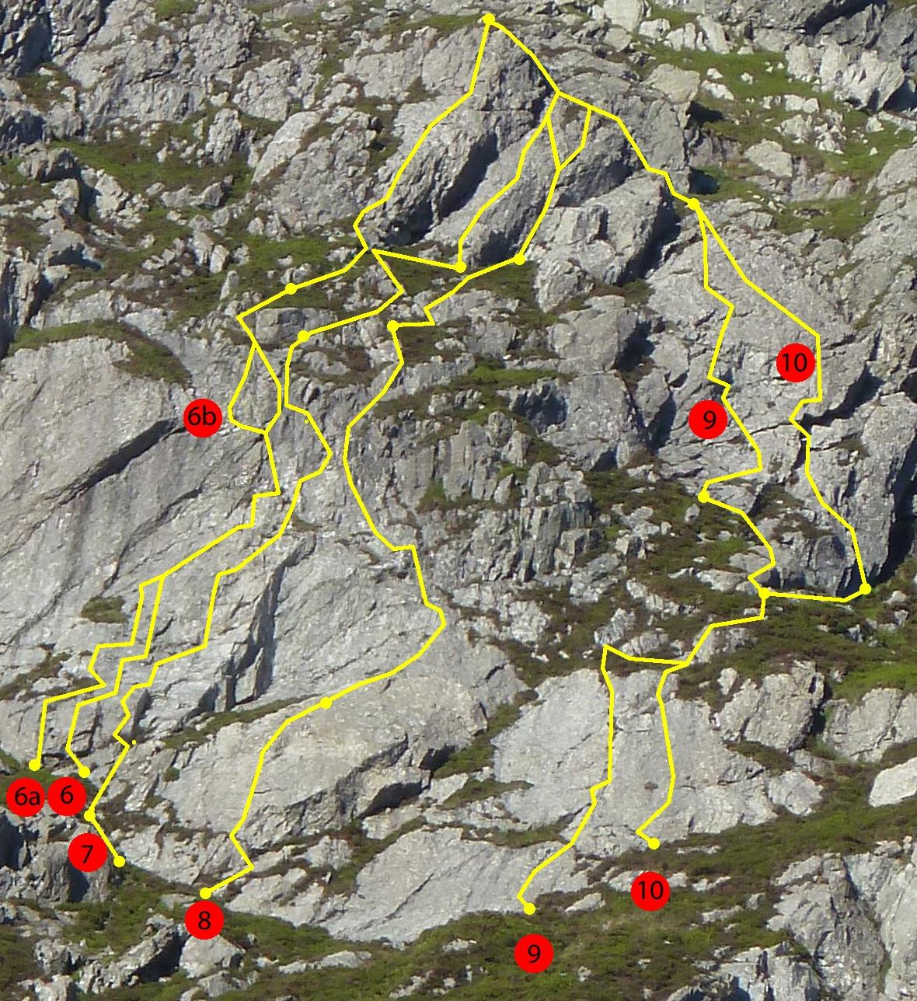
The Slabs Sector routes
5) Papillon, 75 m, E1, 5b/c, 4c **: An excellent route with a long first pitch. Cruxes at the start and near the top of the first pitch provide the main challenge: the lower crux is a finger crack; the upper is a steep, well-positioned groove. Both are well protected. The slab that links them is easier but interesting and surprisingly protectable. The lower steepening of the first slab layer forms a crack-seamed bulge. The original line starts at a small heather ramp at the extreme right hand end of the heathery “ledge” immediately below the bulge and takes the second crack to the left of the right arête of the bulge. The Great Escape Start takes the next crack to the left.
P1. 45 m, 5b/c (the pitch length is given from the foot of the bulge but the belayer can see the leader better from a few metres lower): Step up left off the heathery ramp, surmount the bulge via an undercut and pull steeply up the finger crack on to the slab (the exit holds are sound but take care with the blocks just above). Step right and climb past a tiny ramp to a pocket in a break. Move up and right on to a good foothold in the break. Pull/rock up and work up the slab, eventually slightly leftwards, to a thin diagonal crack. Follow the crack to a ledge on the right. (The pitch could be split here but belay-quality gear is well above.) Go up a short groove and step right to a higher ledge where the rock steepens. Continue steeply up the next groove with difficult moves to reach and pass a jug on the flake in the left rib. Improving holds lead to the exit of pitch one of Eight Days a Week (see ROUTE FINDING NOTE below the Eight Days a Week action photo on p13.). On gaining easy ground, keep left into a niche and exit via its left side to the heathery groove above and a choice of stances and belays.
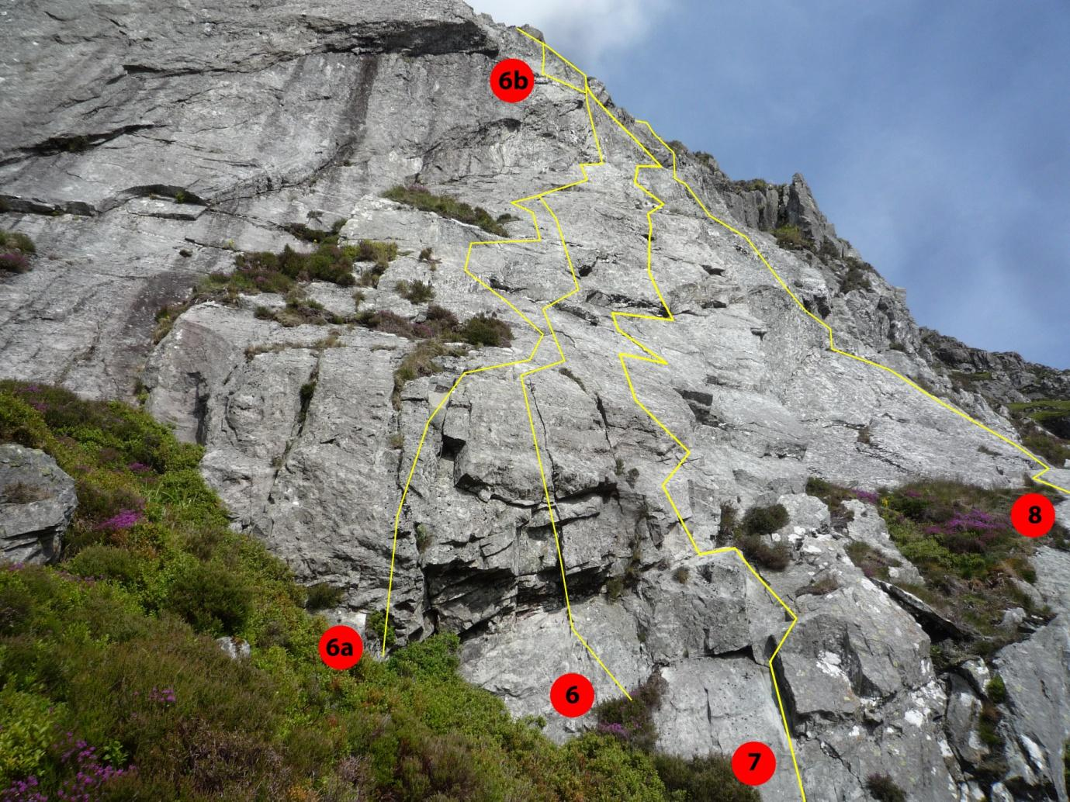
Slab Sector, left hand layer: details of route lines below the heather band
6a) Variation; The Great Escape Start, 5a (start only: the upper crux is 5b/c): Climb the next crack to the left of the original start, traverse right into the normal line to pass the vegetation but bear left from the small ramp to a big foothold (looks like a block but actually seems part of the rock). Stand on the horizontal break above, step right to avoid the next patch of vegetation and climb the slab to a diagonal crack that soon joins the original way.
(NOTE: this start was climbed on sight in mistake for the original start. The slab part had already been cleaned while prospecting the original line. The section through the bottom bulge had not and may still contain some loose rock.)

6b) Variation; The Great Escape Finish, E2, 5b/c: Not led yet, hope to do it soon.

P2. 30 m, 4c: Continue up the heathery groove to a blunt spike below the upper buttress. Gain the highest ledge above from the left (loose rock round to the right). Starting in the groove, bear right to the rib and climb a steepening to a slab. At the top of the slab surmount another steepening then easy ground to the Top Ridge. (Don’t go too far right at the upper bulge: the nearest blocks and cracks to the right seem sound but the outer flakes on the arête look loose and have not been cleaned or tested).
H.Walmsley, C.Calow 15/06/2022, Great Escape Start J. Jones, P. Moore, 10/07/2022, Great Escape Finish ????

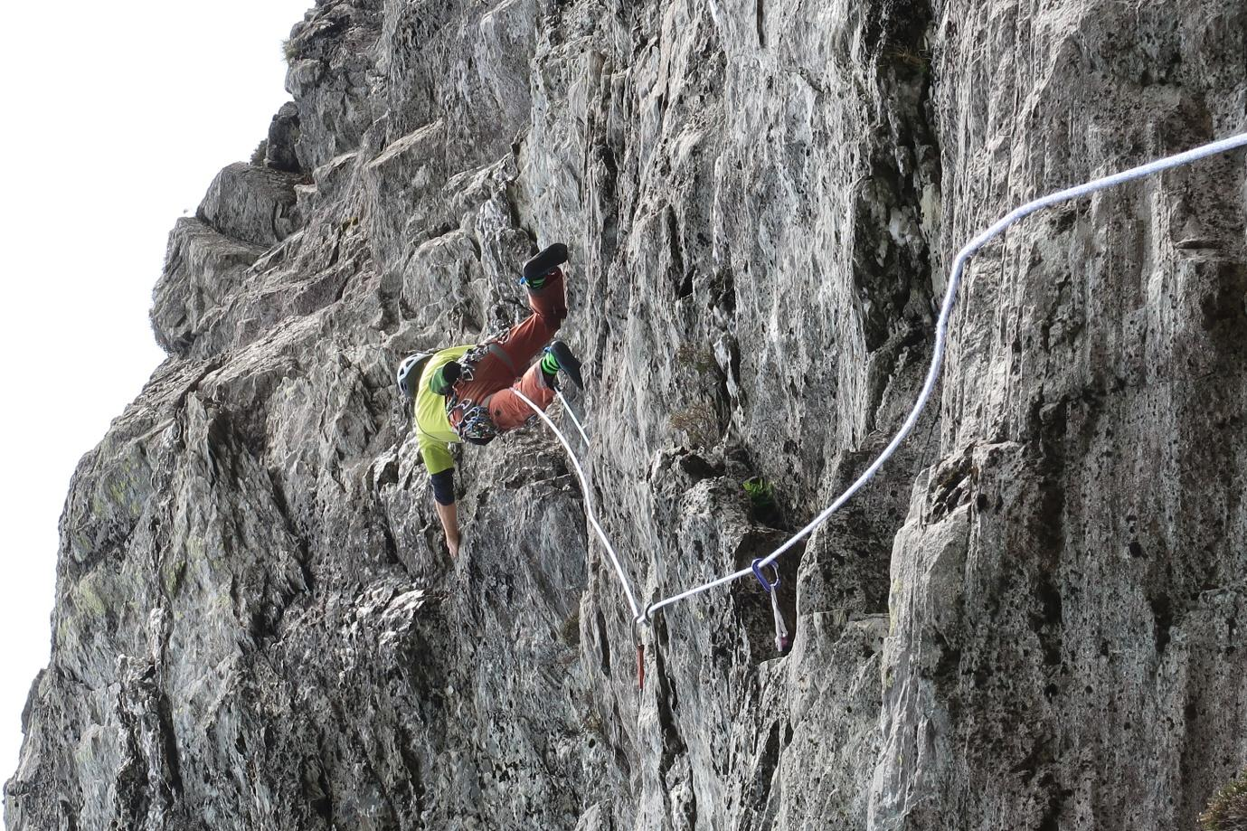
Papillon: approaching the steeper groove at the top of the slab
7) Eight Days a Week, 93 m, E1, 5b, -, 5a, **: Another good route with an excellent, and very long, first pitch. It takes a line near the right edge of the left hand slab layer. Start below the central slab layer at the highest point of the heathery recess.
P1. 53 m, 5b: Scramble up the heather above the recess and step on to the rock from a small pointed block a few metres up the corner. Climb the crack at the boundary between the left and central slab layers over a slight bulge. Step immediately left to a ledge on the rib and climb the left side of the arête to gain the slab. At the first horizontal break above, step right to a tiny left-facing groove and climb it (1st crux) via a pocket to another break. Traverse right below the bulge and surmount it on good holds. Continue up the slab past breaks and pockets until a step right leads to right-facing flakes where the rock steepens. From near the top of the flakes, reach a jug below a sloping ledge and make awkward moves right and up (2nd crux) into a groove. Trend left up shallow grooves to spikes and step left in a good position to the exit groove. Finish more easily to a stance and belay on a ramp up to the right. (Best belays yellow and large blue Dragon cams or equivalent).
P2. 15 m, -: Follow the heathery ramp up and right to a rib, climb it to a blunt rock spike (on Papillon) and traverse right across heather and bilberries to a stance below a big flake at the foot of the final rib. Large cams in the right hand side of the big flake.
P3. 25 m, 5a (can be combined with P2): Climb the flake and the slabby rib above past a delicate move with small spike protection about half way up (easier on the left, better on the right). Gain the ridge and follow it to spike belays where it levels off.
H. Walmsley, C. Calow, M.Bailey, A. Leary, 24/08/2021
NOTE: It is possible to climb almost anywhere on this slab and many link ups are possible. Two examples are: 1) Follow Eight Days a Week through the lower crux then join Papillon to create a direct pitch of nearly 60 m, 2) Do the start and slab of the first pitch of Papillon then the second crux of Eight Days a Week and the upper part of P2 of Another One Bites the Dust for a long left to right diagonal.
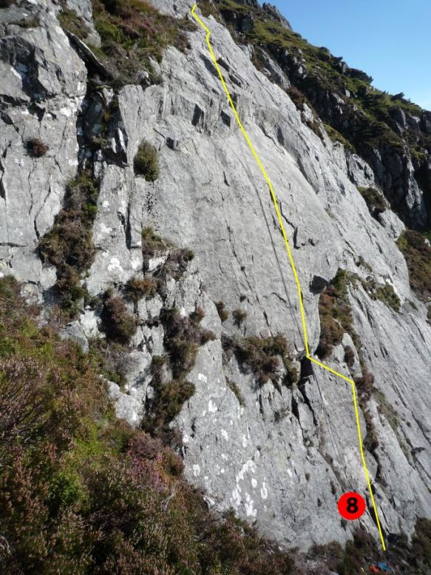
Pitch 1 of Another One Bites the Dust
8) Another One Bites the Dust, 100 m, E1, 5b/c, 5a/b, -, 4c*: Provides varied and interesting climbing up cracks and an overlap in the middle layer of slabs before veering left on to the steeper rock above the left hand slab layer. Start below a big block wedged under an overlap about 10 m right of Eight Days a Week.
P1, 20 m, 5b/c: Swing left on to the block from the slabs to the right. Climb the thin crack above to a slab. Surmount the overlap and continue rightwards to belay on a block in the crevasse and/or a sling round the tip of the crevasse flake.
P2, 40 m, 5a/b: Step off the tip of the flake and follow a thin crack rightwards up the slab. At the steepening, move left on flakes and climb about half way up the left-hand of two grooves. Swing out on a jug in the left arête and climb the wall to a ledge. The groove directly above is dirty and leads nowhere so follow the groove on the left to a jug on its right wall (hidden Rock 5 behind the jug) and gain the ledge above either by escaping round the left rib to good holds or, harder, by continuing directly up the groove. Ribs, slabs and an easy arete then lead to a belay on a spike (a block up left and a medium/large cam up right provide backup).
P3, 20 m, -: A heather link. Step up to the cam and move right to a heathery groove. Bridge up and step right on to a rock shelf. Follow the maximum amount of rock in steps diagonally right passing the last stance on Eight Days a Week. Belay at the base of the corner above or continue.
P4, 20 m, 4c: Climb just right of the corner to a ledge. Start the crack in the rib above awkwardly from the right. It soon eases and leads to the Top Ridge, which is followed easily to spike belays where it levels.
H. Walmsley, C. Calow, 20/09/2021
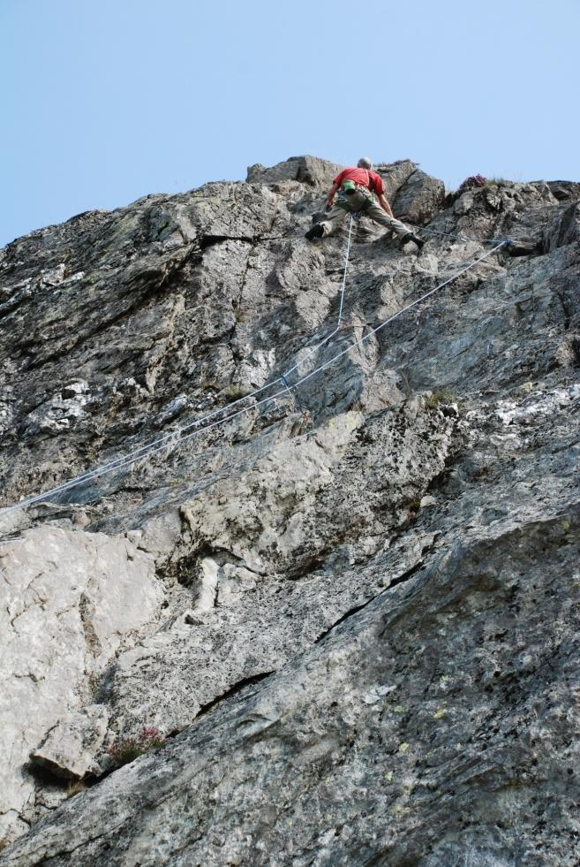 | 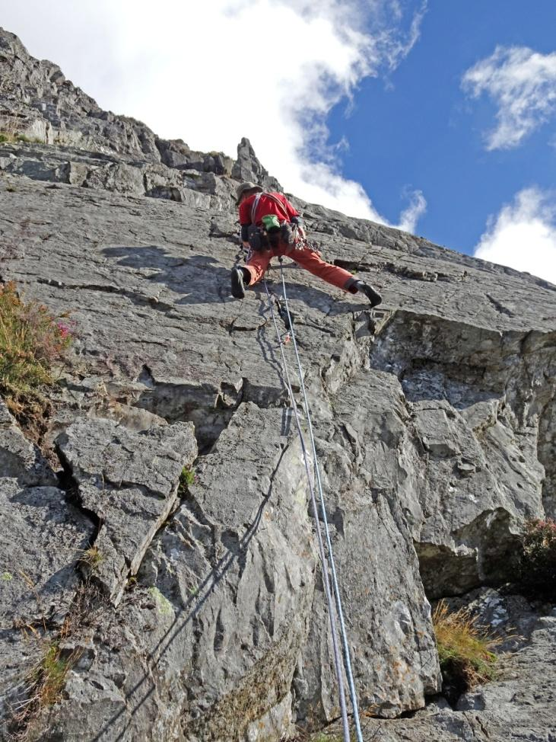
Eight Days a Week: nearing the exit of P1 | Another One Bites the Dust: the thin crack
(PAPILLON ROUTE FINDING NOTE: the top part of Papillon p1 climbs a groove to reach the kinked flake crack in the prow left of the climber in the action photo of Eight Days... then moves either up and right to the Eight Days exit or out left across the steep wall before going up (The Great Escape Finish).)
The final two routes take the right hand layer of slabs and the buttress above.
9) Safety First, 107 m, HVS, 4c/5a, 4c, 5a, -, *: A pleasant pitch up the main crack in the right hand slab layer leads to an interesting groove and face above. Start at the right edge of the lowest slab, slightly above the lowest point of the rock.
P1, 45 m, 4c/5a. Climb the initial slab via an incipient crack and move diagonally right through a gap in the heather. Gain the main crack that runs up the middle of the slab and follow it to good runners in a block at the top. Step down, traverse right to join P1 of Don't Panic and follow it to the twin block belay.
P2, 12 m 4c. Climb the bigger block above the belays starting on the left and stepping right along the lip, then scramble up heather and rocks on the right to the foot of the upper wall.
P3, 35 m 5a. Trend right up slabs then back left into a steepening groove. From the vertical part of the groove, bridge out to the left arete and pull left on to the face using good side-pulls in a hidden crack. Surmount a small overlap directly above then another a little to the right. Move left to a hole and finish more easily up to the ridge.
P4. 15 m, Mod/Diff. Finish (scramble?) up Top Ridge.
H. Walmsley, M. Bailey, A. Leary, 28/06/2021
10) Don't Panic, 92 m, E1, 4c, -, 5b, -, *: The first pitch takes the slab of compact rock to the right of Safety First, starting at a higher level: it is basically a solo; there are no reliable runners until after the junction with Safety First (skyhooks might help?). Both pitches probably deserve E1? Start about 10 m up and right of Safety First at a ramp in the left edge of the higher slab.
P1, 32 m, 4c. From a foothold a few moves up the ramp move right across the lower wall to gain the slab. To the right of a porthole (cleaned out in a futile search for runners) and just left of a grass patch a prominent foothold indicates the way. Climb fairly directly from the foothold. Near the top, move left into a groove (poor nut and small, loose flake) and follow its left rib to a ledge (junction with Safety First). Step right to the arete (first worthwhile runner), climb it to heather, step right, scramble over a small block and belay on the twin blocks above.
P2, 10 m. A heathery link. Scramble rightwards to a small flake at the toe of the upper wall.
P3, 35 m. 5b. Climb steep grooves just right of the flake, exit left to a ledge then step left and up a rib into the groove below the prominent overlap. Move round the left edge of the overlap, mantel on to the ledge above, step right and climb the rib in a good position to small overlaps. Above these trend left on easy ground to the stance at the top of P3 of Safety First.
P4, 15 m. As for Safety First: finish up Top Ridge.
H. Walmsley, M. Bailey 28/06/2021
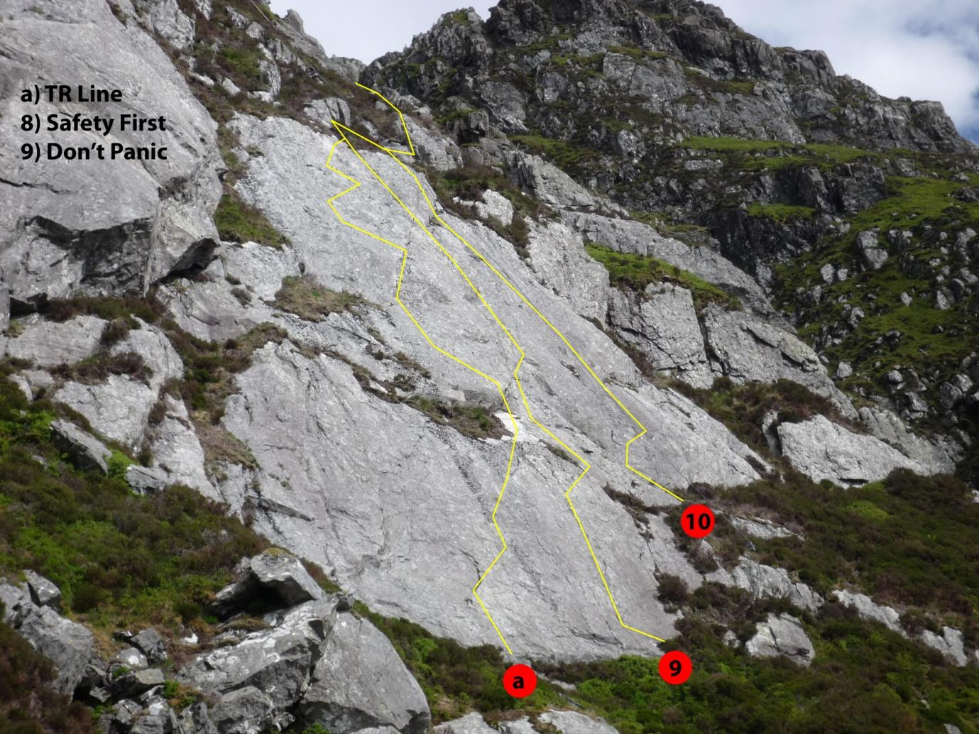
The bottom pitches of Safety First, Don’t Panic and a top rope pitch [a) TR line], as yet unled
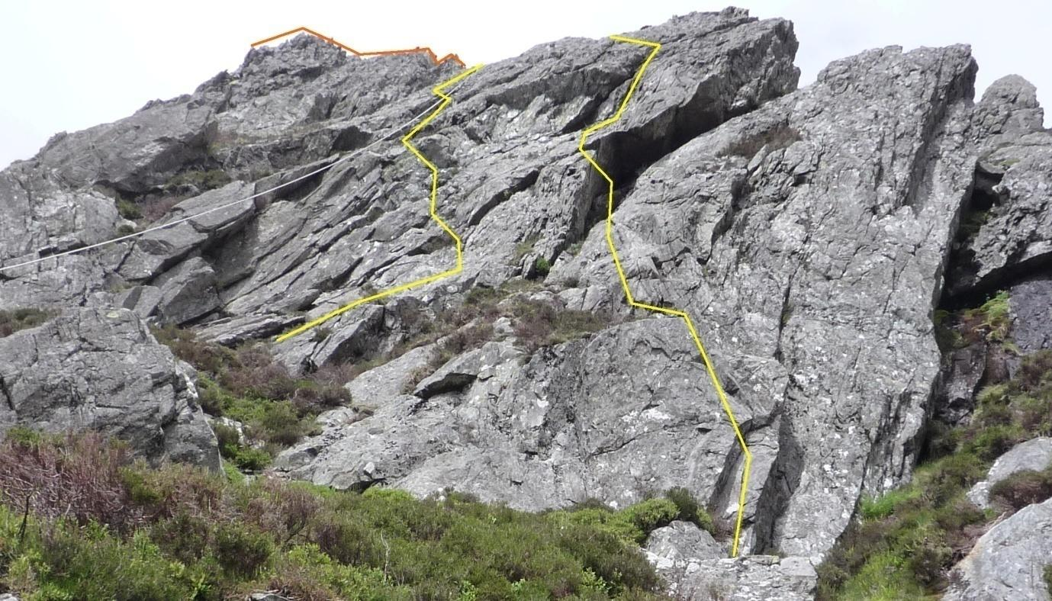
A foreshortened view of the upper pitches of Safety First (left) and Don't Panic (right)
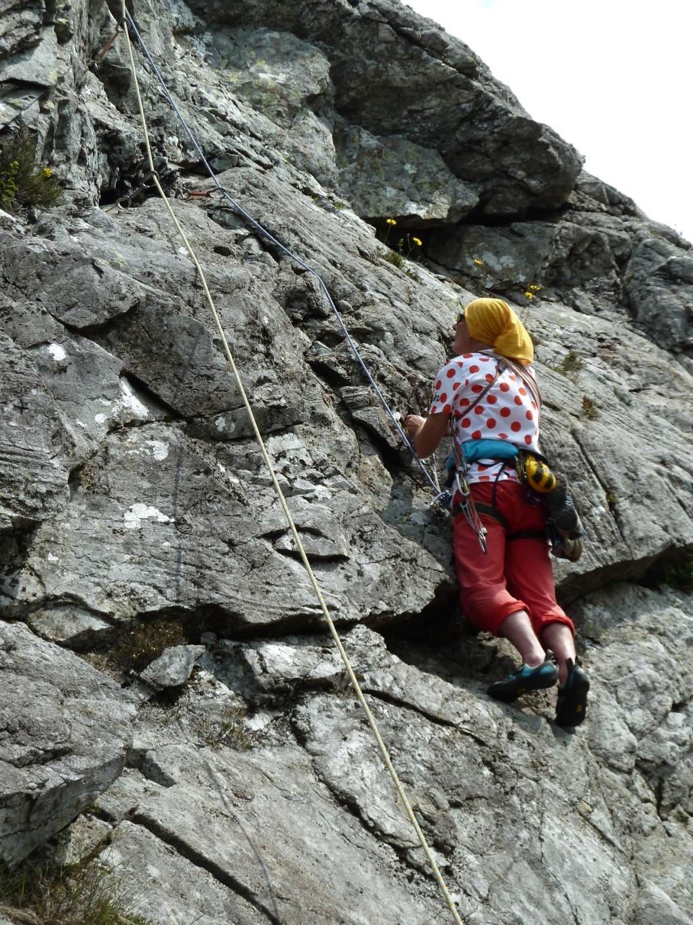
Safety First: the upper buttress (P3)

The anchor was equipped in 2021. It consists of three loops of rope round a big block and through a stainless steel ring. One of the loops is protected by running through a reinforced plastic tube.

